**Deep Learning**

**MAS5005**

**Challenging Task**

**Graphs and Output**

Saraswata Mangal – 23MAS10003

J Karthik Reddy – 23MAS10008

Swarnabha Sengupta – 23MAS10026

Soukarya Raha – 23MAS10035

**Training Loss and Validation Loss Graph By number of epochs**

**Model Used : ResNet50**

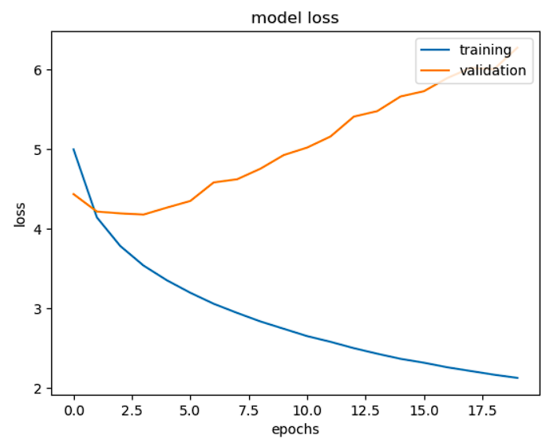

**Predicted Caption by Actual Caption**

